October 20, 2005
It's hard to find special table linens that aren't white and won't break the bank, so when high-end party planners need lots of color and style they go to Magnolias Linens, a tiny store on the Upper East Side (magnoliasgroup.com). It is owned by Anjum Ahmed, center, a Manhattan internist, and her daughters, Asema Asghar, left, and Talaiya Mughal. They will have a tablecloth made in India in any size or color and rent it for an event at $50 to $150 (or sell it for twice that).
The cloths are silk or polyester and look more like saris or evening gowns than table linens; some are embroidered, others painted or embellished with crystals or beads. The store, open by appointment, is at 316 East 84th Street; (212) 472-7708.

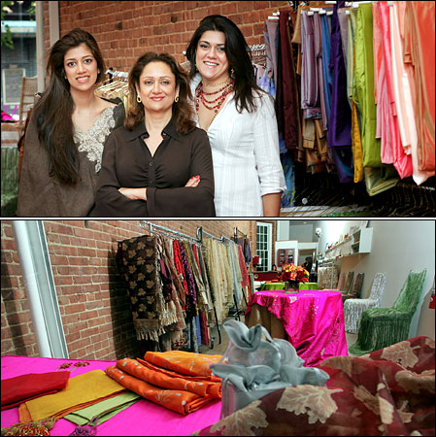
Tony Cenicola/The New York Times

